**Nicole Putnam, Ph.D., of Vanderbilt University**   
[**“The impact of innate immune recognition of Staphylococcus aureus on bone homeostasis and skeletal immunity”**](https://www.niaid.nih.gov/sites/default/files/nicoleputnamapplicationF31.pdf)

**Research Strategy:**

**RESEARCH STRATEGY**

**A, SIGNlFlCANCE**

**A1. *Staphylococcus aureus* is the most common cause of bacterial bone infection (osteomyelitis).**

S. *aureus* is the leading cause of healthcare-associatedinfections, and in otherwise healthy individuals, infections have increased with the spread of community-acquired S. *aureus* strains since the early 2000s (1-4).

S. *aureus* is responsible for approximately 80% of all osteomyelitis cases in humans (5). Colonizationof bone with bacteria occurs by spread from a contiguous soft tissue infection or contamination of the bone following trauma (6). Additionally, children are more likely to establish bone infections via hematogenous spread of bacteria through blood without known risk factors. Osteomyelitis can lead to serious complicationsresultant to alterationsin bone remodeling, forming large areas of bone destruction, aberrant bone formation, and local vasculature damage. Treatment requires drastic measures to eradicate the infection, and antibiotic resistance complicates this already difficult-to-treat invasive infection. The current standard of treatment for osteomyelitis entails surgical debridement of the infected bone and prolonged courses of antibiotics (6). Unfortunately, treatment does not always prevent complications, including pathologic fractures, thomboses, septic arthritis, and growth defects (6). Altered bone remodeling can also be induced by other inflammatory disorders, and understanding how bacterial-inducedinflammation impacts bone remodeling WT

will lead to an enhanced understanding of how systemic inflammatory

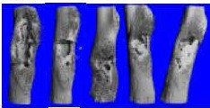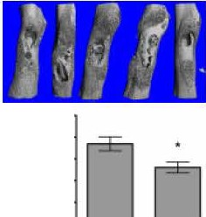

*t,psma1-4*

jl :

'E 0.4

cu .§ 0-6

*8* iii 0 2

·

disorders or alterations in the microbiota affect bone health.

A2. CC-mediated bone loss occurs during inflammatory disease states.

Many disease states significantly alter bone homeostasis and lead to bone loss by perturbing the equilibrium between OBs that deposit new bone and OCs that resorb bone (7,8). Bone loss occurs when OC differentiation is favored leading to excessive bone resorption (7), which can be seen during systemic inflammatory conditions such as rheumatoid arthritis and inflammatory bowel disease (8), as well as locally due to periodontal disease and joint inflammation (9-11). Notably, dramatic local inflammation of bone occurs subsequent to the establishment of S. *aureus* osteomyelis (12).

**A3. S. *aureus* alters normal bone remodeling.**

The presence of S. *aureus* in bone disrupts normal, homeostaitc bone remodeling (13-15). Specifically, a class of staphylococcal toxins, alpha-type

phenol soluble modulins (a-PSMs) are both necessary and sufficient to induce

direct cell death of OBs *in vitro* (12). However, preliminary *in vivo* experiments 0 0 *._._WT _._!)...p..-sam..-...*

·

*._....*

*4*

*1*

have shown that toxin-deficient S. *aureus* strains still induce dramatic **1o """'**

alterations in bone physiology, indicating that other mechanisms also lead to changes in bone during S. *aureus* osteomyelitis **(Figure 1**). OCs are able to resorb bone by forming a localized resorption compartment on bone with a low pH and secreted enzymes to mobilize mineral and digest the organic matrix (16-18). We have observed OC-like cell formation induced by S. *aureus* supernatants *in vitro* (see Preliminary Studies), which implicate an OC­ mediatedmechanism of bone loss during osteomyelitis.

**A4. RANKUOPG axis mediates classic OC differentiation.**

Classically, the cytokine RANKL signals through the RANK receptor of

**Figure 1. Toxin-deficient**

**S. *aureus* induces dramatic bone remodeling.** MicroCT scans of infected femurs on day 14 post-infectionwith WT S. *aureus* or *t,psma1-4* strains were used for 30 reconstruction and quantification of cortical bone destruction.

myeloid cells to drive OC differentiation *in vivo* (19). Mice deficient in RANK or RANKL do not have OCs, resulting in very dense bones, or severe osteopetrosis (20-22). The main source of RANKL necessary to initiate bone resorption *in vivo* is produced by OBs, although RANKL is also expressed by activated lymphocytesand osteocytes (23-26). Tight regulation of osteoclastogenesis is imposed by OBs, as they also produce the soluble decoy receptor, osteoprotegerin (OPG). OPG is an important physiologic inhibitor,in that OPG-deficient mice exhibit osteoporosis (27). To induce osteoclastogenesis RANK signaling must occur on a myeloid lineage cell in the presence of M-CSF, and with co-stimulaiton through immunoglobulin-like receptors TREM2 or OSCAR. Complex signaling pathways during OC differentiationlead to the activation of transcription factors NFKB, AP-1, and NFATc1 to induce QC-specific genes **(Figure2).**

**AS. Innate recognition of S. *aureus* leads to crosstalk with osteoclastogenesis pathways.**

S. *aureus* contains conserved molecular patterns that are recognized by PRRs, to initiate innate immune responses during infection. OB- and QC-lineagecells are known to express PRRs, although their contribution

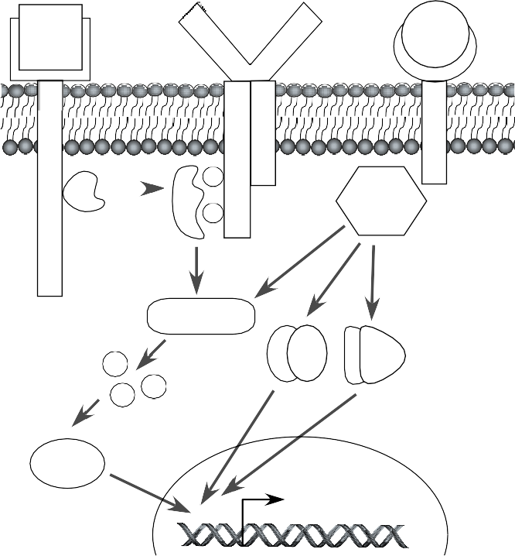to changes in bone physiology and pathogen clearance have not been defined during osteomyelitis. Innate sensing of bacteria and PRR activation leads to activation of transcription factors that are also involved in OC differentiation. Proinflammatory cytokine production downstream of PRRs has also been implicated in non-canonical OC differentiation (36-38). In regards to *S. aureus*, reports on osteoclastogenic effects are unclear due to the use of various pre-OC cultures and stimulation methods (39-42). The field would benefit from the clarity of a mechanism using primary skeletal cells and a clinically relevant strain of

|  |  |  |  |
| --- | --- | --- | --- |
| M-CSF  c-Fms    cSrc  Ca++  NFATc1 | P  Syk  P  PLC-γ | Unknown  ligand RANKL  Ig-like receptor  I T  A TRAF6  M  NF-κB AP-1  Mature OC genes:  *CTSK, ACP5, CTR, DCST2* | RANK |
| **Figure 2. OC differentiation requires RANKL signaling in the presence of M-CSF and co-stimulation from an Ig-like receptor.** M-CSF signaling through its receptor, c- Fms, leads to activation of cSrc kinase to phosphorylate ITAMs on a co-stimulatory Ig-like receptor, allowing for Syk kinase docking. Syk kinase and TRAF6-mediated signaling activate phospholipase C (PLC)-γ to cleave the substrate PIP2. This reaction leads to cytoplasmic mobilization of calcium and activation of the canonical OC transcription factor (TF), NFATc1. RANK signaling through TRAF6 activates additional TFs necessary for osteoclastogenesis, including canonical and non-canonical NFκB and AP-1. In the nucleus, these TFs work together to induce OC-specific genes, *CTSK* (cathepsin K), *TRAP* (tartrate-resistant acid phosphatase), *CTR* (calcitonin receptor), and *DCST2* (DC-STAMP) (28-35). | | | |

*S. aureus*. To address these concerns, we are using an isolate of *S. aureus* (LAC, a USA300-type strain) that represents the most common lineage causing bone infections, which may help clarify previous studies using laboratory or regional strains.

###### A6. OC differentiation is also regulated by cytokine signaling and transcription factor activation.

Positive regulation of osteoclastogenesis occurs through indirect alteration of OB function or direct interaction with pre-OCs (11). Indirectly, cytokines IL-1 and TNFα favor OC differentiation through an increase of the RANKL/OPG ratio (11, 43, 44). Directly, alterations in osteoclastogenic potential of pre-OCs result from enhanced ability to undergo differentiation (45, 46), cell-cell fusion (38), increased survival (38,

41), intracellular signaling (TRAF6, PLC-γ) (47), activation of transcription factors (NFATc1), and receptor expression (RANK, c-Fms). Negative regulation of osteoclastogenesis occurs through decreased receptor expression (RANK, c-Fms, OSCAR, TREM2), decreased RANKL and M-CSF production, suppression of intracellular signaling, increased anti-OC transcription factors, or increased OPG levels (48). The proposed experiments will

explore how *S. aureus* alters pre-OC cell biology via TLR/IL-1R signaling through transcription factor activation, gene expression changes, and functional OC differentiation **(Aim 1)**, and how innate recognition of *S. aureus*

through MyD88-dependent receptors on skeletal cells pathogen clearance during osteomyelitis **(Aim 2)**.

induces physiological changes in bone and impacts

###### INNOVATION

**B1. The effects of *S. aureus* on bone at the cellular and organ level could describe common processes shared between sensing of the microbiota, infection, and inflammatory states.**

Fundamentally, these Aims will determine how skeletal cells respond to microbes and how this leads to drastic changes in immune defenses and bone remodeling. Though RANKL-dependent osteoclastogenesis is well defined as the canonical OC differentiation signal, it has been shown that immunological crosstalk between parallel signaling pathways and transcription factors promote osteoclastogenesis (14, 49). Alterations in cytokines and transcription factor activity have been defined as potential mechanisms for non-canonical (RANKL-independent) osteoclastogenesis (15, 47). We plan to use primary cell culture models of both whole bone marrow (WBM) and bone marrow macrophages (BMMs) to explore differences in cellular stimulation, rather than using cell culture lines or limiting our scope to only one BM culture condition. Disparities in osteoclastogenic changes between WBM and BMM cultures will be revealed at the level of gene and protein expression. Furthermore, though phenotypic analyses are prevalent in the field, functional readouts are lacking in many studies. The proposed experiments aim to elucidate how *S. aureus* alters OC differentiation and function, contributing to the fundamental knowledge of bone biology and improved understanding of innate

immune signaling during osteomyelitis. Information uncovered in these experiments may identify critical bacterial targets to limit bone destruction during *S. aureus* osteomyelitis.

###### B2. Novel genetic mouse models will define the effect of innate sensing by skeletal cells in bacterial clearance and bone remodeling.

In 2013, our laboratory developed a murine model of post-traumatic bacterial osteomyelitis (12). Contrary to larger animal and fracture models of osteomyelitis, this infection model is advantageous for several reasons: we use a genetically tractable animal, we can precisely calculate colony-forming units (CFUs), we do not implant foreign bodies, and we have generated imaging analyses to accurately quantify bone remodeling. To date, many immune mediators hypothesized to alter OC differentiation have not yet been explored in an animal model of osteomyelitis. In addition to testing MyD88-null mice during preliminary studies, this proposal will result in the creation of novel mouse strains with skeletal cell-specific deletion of MyD88. Bone remodeling analyses will be important to determine the function of MyD88 in skeletal cells in the absence and presence of infection. These mice will be powerful new tools for the osteoimmunology field, which investigates the intersection of bone biology and immunology.

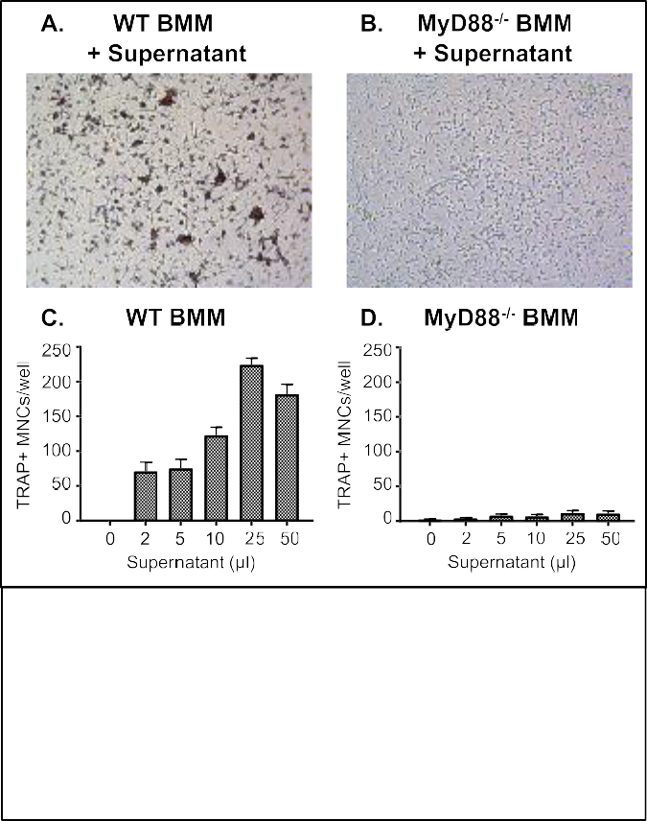

**Figure 3. *S. aureus* supernatants are able to induce OCs from WT, but not MyD88-deficient BMMs.** BMMs were stimulated for 7 days with M-CSF and concentrated

*S. aureus* supernatants (50µl). WT (A) and MyD88 (B) are shown following fixation, TRAP stain, and 20X imaging. TRAP-positive multinucleated cells were quantified manually in triplicate from WT (A) and MyD88-deficient (B) BMM cultures with varying amounts of supernatants.

###### APPROACH

**C1. Preliminary Studies**

**C1A. *S. aureus* supernatants modulate OC** **differentiation.**

Our preliminary data demonstrate that *S. aureus* supernatants modulate differentiation of OCs with and without the canonical OC differentiation factor RANKL, in cultures of whole bone marrow (WBM), containing myeloid, lymphoid, and stromal cells, and in bone marrow macrophages (BMMs). BM cultures were stimulated with *psm*-deficient *S. aureus* supernatants to prevent cytotoxicity resulting from the α-PSMs in *S. aureus* wild-type supernatants. We observed that *S. aureus* supernatants drive BMM differentiation to OC- like cells without the addition of exogenous RANKL **(Figure 3A).** These cells are TRAP-positive, but differ in size and cell fusion from RANKL-treated BMMs. Alternatively, *S. aureus* supernatants inhibit osteoclastogenesis from BMMs following RANKL treatment by limiting the size (data not shown). These data support the notion that in pre-OC cultures, *S. aureus* induces RANKL-independent osteoclastogenesis and inhibits RANKL-induced osteoclastogenesis.

###### C1B. S. aureus supernatants do not modulate OC phenotypes in MyD88-deficient BMM cultures.

The innate immune response to bacteria is often mediated by TLRs and IL-1R, and all TLRs known to recognize *S. aureus* and IL-1 family receptors must signal through the MyD88 adaptor protein. In order to determine if TLR activation or IL-1 family receptor signaling are involved in *S. aureus*-induced changes on pre- OC differentiation, MyD88-deficient BM cells were used for osteoclastogenesis assays. Importantly, RANKL is similarly able to induce OC differentiation in both wild-type C57Bl/6 (WT) and MyD88-deficient BM cells (data not shown). In MyD88-deficient BMMs, *S. aureus* did not induce RANKL-independent differentiation of OC-like cells **(Figure 3B)**, nor did *S. aureus* diminish RANKL-dependent OC differentiation as observed in WT BMM cultures (data not shown). A quantitative analysis shows that *S. aureus* induces a robust, dose-dependent formation of OC-like cells from WT BMM **(Figure 3C)**, but not in MyD88-deficient BMM cultures **(Figure 3D)**.

These data support a MyD88-mediated mechanism by which *S. aureus* perturbs OC differentiation, emphasizing the importance of innate sensing and signaling through MyD88 in modulating osteoclastogenesis.

###### C1C. MyD88 is critical for control of S. aureus replication and dissemination during bone infection.

WT mice show dramatic bone remodeling changes in our murine osteomyelitis model by day 14 post- infection **(Figure 1)**, but they are able to control bacterial replication and do not develop disseminated disease. To assess the role of MyD88 *in vivo* during osteomyelitis, MyD88-null mice were infected using various doses

of *S. aureus*. Our data reveal that MyD88-deficient mice are unable to control *S. aureus* replication, leading to higher bacterial burdens in the infected femur, and increased dissemination to other *S. aureus*- susceptible organs, causing some mice to succumb to disseminated *S. aureus* infection **(Figure 4)**. These data indicate that MyD88 is involved in the initiation of an immune response to *S. aureus* in bone to limit bacterial survival and dissemination.

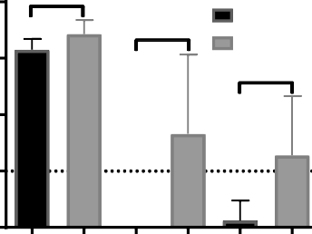

MyD88-/-

*

**Bacterial burden**

* C57Bl/6

**

4

2

0

6

8

**A.**

**Log10(CFU)**

###### C2. Specific Aims

**Specific Aim 1: Define the role of TLRs and IL-1R in *S. aureus*-** **mediated perturbation of osteoclastogenesis.**

Femur Kidneys Liver

***Rationale and Hypothesis:*** Preliminary data show that bacterial components modulate OC differentiation from myeloid cells with and without the canonical OC differentiation factor RANKL by a MyD88- mediated mechanism. Specific TLRs and IL-1 family cytokines require the critical adaptor protein MyD88 to transduce their intracellular signals, emphasizing the importance of innate recognition in modulating osteoclastogenesis. Of unique interest are the TLRs 1, 2, 6, and 9 because they have been implicated in OB sensing of *S. aureus* and signal through MyD88 (7). Extracellular TLR1/2 and TLR2/6 heterodimers are known to engage *S. aureus* lipoproteins (50, 51) and

C57Bl/6 All CFUs MyD88-/- 104 CFUs

MyD88-/- 105 CFUs

MyD88-/- 106 CFUs

4 7 10 14

Days post-infection

50

0

100

**Mortality**

**B.**

**% Survival**

*S. aureus* CpG DNA stimulates TLR9 during bacterial replication in the endosome (52). I hypothesize that *S. aureus* modulates pre-OC cell biology through TLR recognition or IL-1R signaling upstream of MyD88*.* The proposed experiments will characterize the potential of *S. aureus*- specific TLRs and IL-1R in modulating OC differentiation and the inflammatory environment.

**Figure 4. MyD88-deficient mice are unable to control *S. aureus* replication following osteomyelitis, resulting in increased bacterial burdens and death.** WT C57Bl/6 and MyD88-deficient mice were infected with 105 CFUs. At day 14, CFUs were enumerated from the inoculated femur, kidneys, and liver (A). A mortality curve shows enhanced death in MyD88-deficient mice even if the infectious dose was dramatically reduced (B). * p < 0.05, ** p < 0.01.

###### Aim 1A: Determine effects of bacterial stimulation, TLR ligation, and IL-1 signaling on osteoclastogenesis in primary BM cultures.

***Experimental Design:*** Osteoclastogenesis assays will be performed in primary murine WBM or BMM cultures from 8-12 week old, male C57Bl/6 mice and mice deficient in TLR2, TLR9, or IL-1R. Mice deficient in TLR2 will be unable to signal through TLR1 and TLR6, as they require

TLR2 to signal. Preliminary data show no difference in OC differentiation in male versus female BM (data not shown). BM cultures will be supplemented with M-CSF and with or without RANKL (46). To determine the effects of bacterial and TLR/IL-1R stimulation between RANKL conditions, BM cultures will be stimulated the following day with bacterial supernatants, TLR agonists, recombinant IL-1, or vehicle controls. BM cultures treated with M-CSF (negative control) will monitor baseline osteoclastogenic phenotypes, whereas BM cultures stimulated with M-CSF and RANKL (positive control) will monitor normal OC differentiation *in vitro.*

After seven days, cultures will be fixed and stained for expression of tartrate-resistant acid phosphatase (TRAP). TRAP is an enzyme dramatically upregulated during OC differentiation, which makes it a widely accepted histochemical marker for identification of mature OCs (53). Quantification of OCs from these assays will be completed using the OsteoMeasure software in the Vanderbilt Center for Bone Biology (VCBB) facility, with OCs defined as TRAP-positive cells with 3 or more nuclei present **(Figure 3)**. Finally, the functional ability of TRAP-positive, multinucleated cells to resorb bone will be assessed by differentiating BM cultures on dentin chips, which are small sections of hydroxyapatite-mineralized organic matrix similar to bone. Functional OCs will be defined by their ability release soluble cross-linked type I collagen peptides (Ctx-1) and form resorption pits on the dentin surface. Ctx-1 will be quantified using an ELISA and dentin will be stained with 0.5% toluidine blue to visualize resorption pits (28). These experiments will provide phenotypic and quantitative data of how bacterial, TLR, and IL-1 stimulation alter differentiation of BM-derived OC-like cells, and more importantly, if these conditions induce functionally resorbing OCs.

***Anticipated Results, Potential Problems, and Alternative Approaches:*** Modulation of OC differentiation has been published elsewhere to occur by divergent mechanisms, where non-canonical OC-specific signaling has induced TRAP-positive *multinucleated* cells with dramatically reduced ability to resorb bone, as well as TRAP-positive *mononuclear* cells that are unable to fuse but are still functionally active (15). Based on the supporting data for this aim, both outcomes are plausible. We expect that if our IL-1R-deficient BMMs differ

from WT during OC differentiation, this may reflect IL-1 produced by cells recognizing pathogens through TLRs, or inflammasome activation through NLRs. We will test this by adding recombinant IL-1R antagonist to cultures and testing cells from mice deficient in critical components of the inflammasome.

It is possible that we will see no bone resorption over the course of a 7-day assay, in which case we will lengthen our assays, as other groups perform culture resorption assays over the course of 14 to 21 days. Additionally, if select TLR- or IL-1R-deficient mice do not express robust phenotypes, we will test BM cultures from the NOD intracellular receptors capable of recognizing cytoplasmic *S. aureus* (54, 55), or other IL-1 family cytokine-deficient mice*.* In total, Aim 1A will provide quantification and functional analysis of OC-like cells to characterize the extent of differentiation down the OC lineage due to *S. aureus* and TLR stimulation *in vitro*.

###### Aim 1B: Define expression of TLRs and OC-modulating receptors on pre-OCs throughout osteoclastogenesis.

***Experimental Design:*** In order to determine changes in expression of receptors, TLRs, and other known factors that modulate OC differentiation, we will isolate RNA over the course of our osteoclastogenesis assays, and use quantitative RT-PCR (qRT-PCR) to measure transcripts of the corresponding genes. Specifically, we will monitor RANKL and OPG transcription, which balance the main axis that controls bone homeostasis *in vivo* (14, 37). We will also measure transcripts from receptors with the ability to alter osteoclastogenic potential of cells, such as RANK, c-Fms, OSCAR, or TREM2 necessary for pre-OC signaling (22, 56), and the newly described RANKL-binding, inhibitory receptor LGR4 (57). Importantly, Aim 1B will define the TLR repertoire expressed throughout the course of differentiation to determine how OC differentiation impacts TLR expression. These data will describe the RANKL/OPG axis *in vitro*, and define which receptors may be necessary for the promotion or inhibition of osteoclastogenesis.

***Anticipated Results, Potential Problems, and Alternative Approaches:*** We expect that RANKL and OPG levels will not be dramatically altered in BMMs, as myeloid cells are not described as a major source of either *in vivo*. However, WBM cultures may allow for production of these signaling molecules. We expect that receptor expression of RANK, OSCAR, TREM2, LGR4, or TLRs varies over the course of differentiation. These experiments will provide potential upstream mechanisms in pre-OCs that lead to altered OC differentiation upon exposure to *S. aureus*. We may find that these receptors remain constant at the mRNA level, in which case protein levels will be monitored using Western blots.

**Aim 1C: Measure how *S. aureus* alters osteoclastogenic signaling pathways and transcription factors. *Experimental Design:*** Osteoclastogenic signaling is complex, and many components crosstalk with other immune signaling pathways. To determine if *S. aureus* modulation of OC differentiation is due to signaling changes, qRT-PCR will be performed on the transcription factors NFATc1 and Blimp1, which require an increased expression to induce OC differentiation. Activation of signaling components will be analyzed using Western blot detection of activated proteins (PLC-γ, p38, IκBα, cFos) using phospho-specific antibodies (58), and preparation of the nuclear fraction to detect translocated NFATc1 and c-Jun using subcellular fractionation. Additionally, mature OC marker expression will be measured throughout stimulation, including DC-STAMP, cathepsin K and the calcitonin receptor (22, 56). These experiments will determine perturbations of normal RANKL-mediated osteoclastogenesis and define the signaling elements activated by *S. aureus* over the course of differentiation.

***Anticipated Results, Potential Problems, and Alternative Approaches:*** We expect that functionally active OC-like cells phenotyped in Aim 1A will display typical OC signaling activity throughout differentiation, such as the upregulation of NFATc1 and Blimp1 and expression of mature OC markers such as cathepsin K and the calcitonin receptor, regardless of RANKL-stimulation. Furthermore, we expect that inhibition of RANKL- stimulated osteoclastogenesis will cause a decrease in osteoclastogenic signaling, relative to RANKL treatment alone. To rule out differentiation toward other myeloid cell lineages, we will test for M1 and M2 macrophage differentiation, by measuring mRNA expression of *nos2* and *arg1*, respectively. If issues arise with detection of phosphorylated signaling molecules, signaling changes that occur before cell-cell fusion will be analyzed using intracellular flow cytometry after fixation, permeablization and incubation with fluorescently labeled phospho-specific antibodies. Taken together, these data will detail how bacterial stimulation specifically modulates OC differentiation and function through TLR sensing and IL-1 signaling.

###### Specific Aim 2: Elucidate the role of skeletal cell-specific MyD88 signaling on pathogen clearance and bone remodeling during S. aureus osteomyelitis.

***Rationale and Hypothesis:*** Aim 1 will identify changes in OC differentiation and function induced by *S. aureus*, and will define the roles of innate immune sensors in these processes *in vitro.* Supporting data show that mice completely lacking MyD88 are more susceptible to *S. aureus* osteomyelitis, leading to increased

bacterial burdens in bone, systemic dissemination to liver and kidneys, and death **(Figure 4)**. I hypothesize that innate sensing of *S. aureus in vivo* by OBs and OCs will alter bone remodeling through signaling and induction of inflammation. The experiments outlined below will elucidate the role of downstream signaling through MyD88 on limiting *S. aureus* infection during osteomyelitis and in boneremodeling alterations.

###### Aim 2A. Determine how skeletal cell-specific MyD88 influences S. aureus clearance from bone and dissemination to other organs during osteomyelitis.

***Experimental Design:*** Our *S. aureus* osteomyelitis model has previously been used to infect WT and MyD88- deficient mice **(Figure 4)**. To determine if MyD88 signal transduction is critical in skeletal cells during *S. aureus* osteomyelitis, we will infect skeletal cell-specific MyD88 knockout mice created with Cre-Lox breeding schemes. MyD88-floxed mice will be bred to Osteocalcin-*cre* and Cathepsin K-*cre* mice to create mice with MyD88-deficient mature OBs and OCs, respectively. To determine how immune defenses are affected when skeletal cells are unable to activate the downstream signaling through MyD88, *S. aureus* CFUs present at the primary infection site and distant organs will be enumerated following development of osteomyelitis.

***Anticipated Results, Potential Problems, and Alternative Approaches:*** The creation of novel skeletal cell- specific knockout mice will allow us to determine the importance of MyD88 signal transduction in skeletal cells during bone infection. Specifically, we expect to observe changes in the ability of mice to limit *S. aureus* infection. MyD88 transduces many signals to mount an innate immune response, which likely led to the mortality phenotype in MyD88-deficient mice **(Figure 4B)**. However, we do not expect as severe of a mortality phenotype in cell-specific knockout mice. If mortality does remain prevalent, we will test a range of inocula between 103-106 CFUs. Additionally, the role of MyD88 in skeletal cell *precursor* cells may be of interest. Cell- specific deletion of MyD88 in OB and OC precursors can be accomplished by crossing MyD88 floxed mice with Osterix-*cre* or LysM-*cre* mice, respectively. However, these models are likely to have deletions in other cell lineages. Alternatively, to identify changes in MyD88 signaling through pre-OCs, BM transplants between WT and MyD88-deficient mice will be done, as OBs and mesenchymal cells are resistant to radioablation (59).

###### Aim 2B. Quantify changes in bone remodeling and osteoclastogenesis in vivo during experimental S. aureus osteomyelitis.

***Experimental Design:*** Quantitative changes in bone architecture that occur during *S. aureus* osteomyelitis will be measured with the assistance of the Vanderbilt University Institute of Imaging Science (VUIIS) (see letter of support from Dr. Dan Perrien). Mock-infected bones will be used as an uninfected healing control relative to infected femurs from the same mouse strain to avoid direct comparisons between different mouse genotypes. To quantify bone remodeling, microCT will be used to measure cortical bone changes around the inoculation site and trabecular bone architecture, including bone volume/trabecular volume (BV/TV), trabecular thickness, trabecular spacing, and trabecular number.

Osteoclast changes during *S. aureus* osteomyelitis will be defined using histologic analyses of infected bone, with support from the VCBB facility (see letter of support from Josh Johnson). Following microCT scans, femurs will be decalcified and embedded for sectioning and staining with bone-specific hematoxylin and eosin and TRAP stains. OCs will be quantified from histological sections by counting TRAP-positive MNCs next to trabeculae in infected or mock-infected femurs. Bone resorption activity of OCs will also be monitored *in vivo* using a calvarial injection model, where concentrated *S. aureus* supernatants or vehicle control will be injected over the calvaria for 5 consecutive days. Resorption pits on calvaria will be quantified after 9 days using microCT analysis, and the mineral apposition rate (MAR) and bone formation rate (BFR) will be quantified using histologic measurement of calcein fluorescent double labels incorporated into the bone.

***Anticipated Results, Potential Problems, and Alternative Approaches:*** We expect that changes in OC number and bone resorption will be discovered *in vivo* following stimulation with live *S. aureus* or concentrated supernatants. Specifically, we expect that *S. aureus* recognition or the induced proinflammatory cytokine response will promote OC differentiation. It is possible that defects in immunocompromised mice will lead to higher bacterial burdens at day 14 post-infection, which will complicate bone destruction data. To mitigate this issue we can surround mock-infected femurs from WT or cell-specific MyD88-deficient mice with scaffolds eluting heat-killed bacteria or concentrated supernatants, as previously described in a manuscript from our lab, to determine the effect of bacterial components on bone remodeling (60).

**Collectively, these Aims will elucidate bacterial-induced mechanisms of altered bone remodeling and osteoclastogenesis, and will further define the ability of skeletal cells to respond to innate immune mediators, including pathogen associated molecular patterns and IL-1 family cytokines.**

**Nico Contreras, University of Arizona**

[**“The Immunological Consequences of Mouse Cytomegalovirus on Adipose Tissue”**](https://www.niaid.nih.gov/sites/default/files/F31-sample-application_nico_contreras.pdf)

**Research Strategy:**

1. **SIGNIFICANCE**. Cytomegalovirus (CMV) is a ubiquitous betaherpesvirus that infects a large percentage of people worldwide1,2–4. Infection progresses from an acute replicative cycle leading to a latent and lifelong infection5,6. can be damaging in the immune compromised such as immune suppressed transplant patients, Human Immunodeficiency Virus (HIV) patients, Acquired Immunodeficiency Syndrome (AIDs) patients, and unborn fetuses6–9. The hallmarks of CMV disease progression are not seen in immune competent patients, and this is a result of the significant amount of resources that the adaptive immune system dedicates to control CMV infections. In fact, 5-10% of CD8 T cells during a primary CMV response can be specific for an antigen generated by CMV12–15. The magnitude of this response is largely unparalleled in any other infection, and due to this, CMV has been investigated for its role in age-related T cell memory inflation3,5,16–18. Studies of CMV T cell inflation and viral dissemination throughout the host have largely been focused upon spleen, lung, liver, blood, and salivary glands13,19–22. These studies demonstrate that cell-free virus is spread in fluids that come into contact with mucosal barriers, such as saliva and breast milk20,23. However, the contribution of T cells and monocytes to the immune response, dissemination, and control of persistence *within* adipose tissue has never been interrogated. Many cells involved in the control and spread of CMV are all represented within adipose tissue (Figure 1), and recent reports have demonstrated the viral and parasitic effects on adipose tissue28–30.

Adipose tissue is a heterogeneous tissue found at a variety of anatomical locations31,32. Visceral adipose found on the trunks of humans and mice is home to a large proportion of

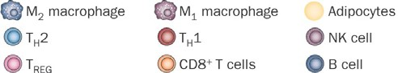

**Figure 1: Immune Cells in Adipose**

**Fig 1.** The immune system is represented in adipose tissue. During homeostasis anti- inflammatory macrophages and Tregs predominate. Adapted from Sell, H. *et al* (2012) *Nat. Rev. Endocrinol.*

cells of the innate and adaptive immune systems33–37. Long thought to simply be a site of lipid synthesis and energy storage31,32,38, adipose tissue is now regarded as the crossroads between host metabolism and immune system communications39–42. Indeed, adipose tissue is resident to T cells, B cells, macrophages, dendritic cells, NK cells, among others33,35,36,43. Investigation of infections and their effect on adipocytes have also increased interest in adipose tissue as an immunological site.

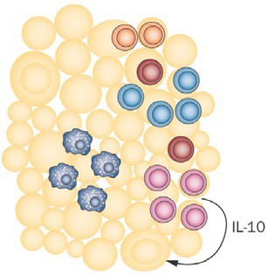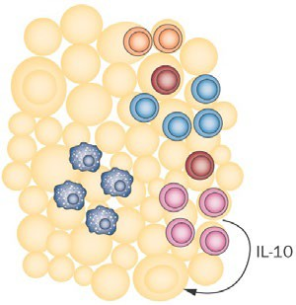

Futhermore, adipose tissue of HIV and SIV infected humans and monkeys harbored latent virus51. Given these observations, as well as our own preliminary data demonstrating a murine CMV (mCMV) specific CD8 T cell expansion in adipose tissue at 7 days post infection with mCMV (Figure 3), in comparison to uninfected mice, *we propose that adipose tissue is a location of productive mCMV infection and can possibly represent a site for persistent mCMV as well.*

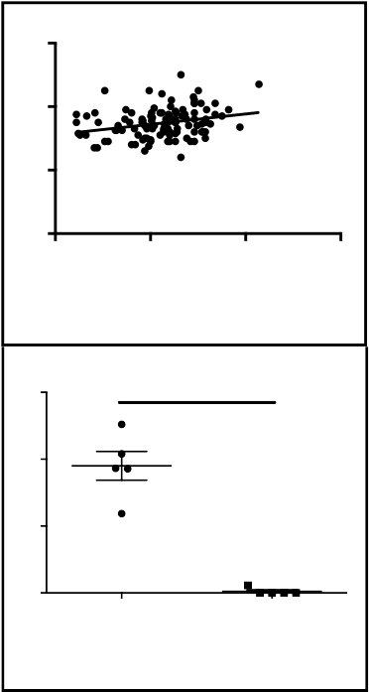

**Figure 2: Waist vs CMV Index Grouped**

**60**

**40**

**20**

**0**

**0**

**5**

**10**

**15**

**CMV Index**

**Fig 2.** Waist Circumference as a function of CMV Index as quantified by Gold Standard CMV kit. Data gathered from Maecker et al. ImmPort Database. Pearson Correlation test p-value = 0.0042

**15**

**Figure 3: %M38+ of CD8+ T cells**

****

**10**

**%**

**5**

**0**

**mCMV+**

**Naive**

**Fig 3.** Increased frequency of mCMV m38 specific CD8 T cells in the adipose of infected C57BL/6 mice at 7 dpi. Significance determined by two-tailed unpaired t test. p-value < 0.0001

**Waist circumference**

This proposal is of significant clinical and biological importance as CMV is a high vaccine priority52 and there have been no studies demonstrating the immune response within adipose tissue specific to mCMV. An understanding of the immune response to mCMV within adipose tissue and potential identification of a latent reservoir for mCMV will allow for more pointed future therapeutic and vaccine designs.

1. **INNOVATION.** CMV infection and the immunological consequences within adipose tissue have never been described. This proposal will provide clear evidence that adipose tissue is a site of active viral replication and a location for a productive immune response against mCMV during infection. This work represents a significant conceptual advancement in our understanding of host- pathogen interactions, and mCMV cellular tropism. Furthermore, the work described in this proposal will advance the development of vaccines against CMV by demonstrating the need for considering adipose tissue specific immune responses.

Development of new technologies for the detection of virus study is crucial for

understanding host-pathogen interactions. While not the primary objective, the

technical innovation of this proposal stems from the development of next generation RNA Prime Flow Probes specific for viral gene transcripts to be used in flow cytometry analyses.

1. **APPROACH.** Preliminary Data. Analysis of data17 uploaded by Maecker et al. to the Immunology Database and Analysis Portal (ImmPort) revealed a correlation between adiposity as indicted by waist circumference53,54 (Figure 2) and CMV Index as assayed by Gold Standard Biotechnologies CMV ELISA. These results indicated to us that adipose tissue could play a role in CMV infection, either serving as a primary site of replicationor

allowing for increased viral load, or both. Lending more weight to these hypotheses are published reports demonstrating that increasing levels of adipose tissue are also correlated with increased pathogen burden55,56.

These observations led us to explore what occurs within adipose tissue during acute mCMV infection of C57BL/6 mice. Mice were infected intraperitoneal (IP) with 3x105 pfu of mCMV and sacrificed at 7 days post infection. Abdominal (pre-epididymal) adipose tissue depots were harvested and stained for analysis by flow cytometry. We employed a very simple phenotype and tetramer panel (Viability, CD4, CD8, m38 tetramer) to determine if there are an increased number or frequency of virus specific CD8 T cells in adipose tissue during acute mCMV infections. As can be seen in Figure 3 the CD8 T cells harvested from infected adipose tissue are significantly increased in comparison to uninfected mice. We fully expected this to be the result, however this data has not been previously reported. These results would suggest mCMV is infecting a component of the cellular constituents within adipose tissue and driving an adaptive immune response. Alternatively, mCMV antigen could be being presented within adipose regardless of productive replication or virus specific CD8 T cells are searching for their cognate antigen in this location following infection.

The long-term goal of our research is to identify the lifelong immunological consequences of CMV infection. The objective of this proposal is to determine if mCMV establishes a productive infection within adipose tissue. Additionally, we seek to determine mechanisms by which mCMV spreads to adipose tissue, if it does, and how antigen specific CD8 T cells arrive to adipose. **The primary hypothesis of this proposal is that mCMV disseminates to adipose tissue, replicates, establishes latency, leading to an lifelong CD8 T cell response.**

All experiments will use male mice 6-12 weeks of age from the C57BL/6 background. We use males to control for sex hormones, and microbiota differences57. We also use this background to take advantage of several established transgenic mice. Cohort size and design will be described within the following aims and sub-aims and are based upon power requirement analysis. By power analysis group sizes of 8 experimental and 8 control animals will allow for detection of >50% effect size between groups at β=0.80 and α=0.05. All experiments will be carried out, independently, at least twice. All mice will be maintained in the specific pathogen free (SPF) animal facilities at The University of Arizona. Procedures will be performed in strict accordance with The University of Arizona Animal Care and Use Committee requirements. Adipose tissue described herein will refer to the abdominal fat of mice found within the peritoneum and surrounding the intestines. This fat pad has been published as pre-epididymal, epididymal, perigonadal, and visceral adipose.

**AIM 1: Evaluate adipose tissue as a reservoir for replicative and persistent virus.** mCMV reaches replicative latency following acute infection. Salivary glands release virion long after initial infection in both mice and humans20,58,59. It has been difficult to identify the cell that is most responsible for maintenance of persistent viral genome as many cells are susceptible to infection, with several studies implicating cell of the myeloid lineage60–62. mCMV research has shown many cells of the adipose tissue, in different contexts, as being important for spread and control of mCMV. It is necessary to investigate adipose tissue as a possible site of mCMV persistence. The *objective* of this aim is to determine the extent that adipose tissue serves as a reservoir for both replicative and persistent mCMV. We will test the *working hypothesis* that the cellular constituents of adipose tissue can serve as a site for active viral replication and following acute infection are sites of viral latency and persistence. We will test our working hypothesis by the *approach* of quantifying viral load within adipose tissue in comparison to previously identified replication and persistent sites. We will determine the extent that adipose tissue cellular constituents harbor latent virus by pharmacological, radioactive, and tissue explant reactivation of virus. Finally, we will determine the viral load of individually sorted cells of both the stromal vascular fraction and adipocyte populations. The *rationale* for this aim is that successful completion of the proposed research will contribute to the identification of persistent mCMV replication sites, which to this point have been difficult to identify. The identification of these latent sites of infection will provide a targeted location for the development of novel therapeutics designed to completely clear CMV. When the proposed studies of Aim 1 have been completed, it is our *expectation* that adipose tissue will have been identified as a site of persistent viral replication.

During infection, does mCMV replicate within adipose tissue? Currently it is unknown what consequence, if any, mCMV has within abdominal adipose tissue. We have observed inflationary12,19,65 m38 specific CD8 T cells in acutely mCMV-infected adipose tissue from mice. While it is not surprising to observe an immune response in this location, we have found no reports demonstrating mCMV specificity. The expansion of CD8 T cells in adipose tissue in response to mCMV leads us to *the hypothesis that mCMV is actively replicating within adipose tissue*. Alternatively, it could be that mCMV specific CD8 T cells are searching for cognate antigen within adipose tissue rather than being activated. This, sub-aim will determine if adipose tissue serves as a site of viral replication during acute mCMV infection. To assess adipose tissue as a virally replicating site during acute infection we will infect 24 adult C57BL/6 mice, and compare viral load to 24 uninfected C57BL/6 mice.

We will use the well-characterized Smith strain of mCMV66–69 and infect with 3x105 plaque forming units (pfu)

by intraperitoneal (IP) injection. At days 3, 7, and 14 post-infection we will sacrifice mice by isoflurane euthanasia. At each time point we will sacrifice 8 mice from the infected and uninfected groups. Adipose tissue, PBMCs, spleen, and salivary glands will be taken for viral quantification at each time point. We will determine viral load by plaque assay as previously described58,70,71 and by quantitative (qPCR) against DNA, to determine viral load, and reverse transcribed cDNA to determine level of activation, of mCMV Immediate-Early 1 gene (IE-1) as well as Late (L) gene gB72–75. Tissues will be weighed and cut in half to quantify viral load per gram. Half of the tissue will be used for plaque assay on the 3T3 mouse embryonic fibroblast (MEF) line as previously described76. The remaining half of tissues will be taken for DNA/RNA extraction, as previously described77–79, and copy number of IE-1 and gB will be determined. As a control in qPCR we will determine copy number of GAPDH. The data will be analyzed using GraphPad Prism using a Two-sample Student’s T test between the same tissues and products (I.E. uninfected adipose vs. infected adipose). A p-value < 0.05 will be considered statistically significant.

Anticipated Results. It is expected that the viral load of adipose tissue to be comparable to that of spleen at day three and seven post-infection. At day fourteen post-infection we expect to see a reduction in viral load in adipose tissue and an increase in salivary gland as has been reported58,69,80. We anticipate that plaque assays at these time points will be sufficient to detect replicating virus. From these experiments we will have established adipose tissue and its cellular constituents as a site for productive mCMV replication.

Pitfalls and Alternatives. Our laboratory has experience with cell culture and it is not anticipated that these experiments will be technically challenging. The gold standard for mCMV plaque assays has been the use of MEFs but these cells are not immortalized and therefore must be repeatedly produced and stocks can vary from lot to lot. If these cells do not yield interpretable data or do not form plaques we will switch to a newly described protocol that allows for greater viral spreading during assay70. It is entirely possible that mCMV does not replicate within adipose tissue. This is not our expectation based upon the increased presence of mCMV specific CD8 T cells in comparison to uninfected adipose. If we find no virus, this would suggest that CD8 T cells are either searching for their cognate antigen or were trafficking through adipose at the time point we looked. Even if this null result occurs the presence of CD8 T cells within adipose tissue even without detectable actively replicating virus raises the following questions (i) what signals are these mCMV specific T cells receiving to traffic to adipose tissue and (ii) is antigen being presented in the absence of viral replication within adipose tissue? The sub-aims to follow this will seek to address these questions regardless of viral replication or not and therefore this is not a hindrance to this proposal.

Does the stromal vascular fraction (SVF) or buoyant adipose fraction of adipose tissue contribute higher viral load? In order to study the stromal vascular fraction of adipose tissue by flow cytometry it is necessary to separate SVF cells from adipocytes81,82. During processing a centrifugation step separates the buoyant adipocytes and macrophages and leaves the pelletable SVF. The floating fraction and the pelleted fraction are a heterogeneous mixture of cells found within adipose tissue. Both fractions are potential targets for mCMV infection83–85. We will infect 16 C57BL/6 mice with 3x105 pfu of Smith mCMV by IP injection and at days 3 and 7 post infection we will sacrifice 8 mice each and harvest adipose tissue. We will process adipose tissue as previously described81,82,86, but once we reach the fractionation step we will culture the SVF and the buoyant fraction, separately, on a monolayer of MEFs to determine what component of adipose tissue contains infectious virus. Cells from SVF and buoyant layer will be quantified by hemacytometer, serially diluted, and added to a monolayer of MEFs in RPMI media with 10% fetal bovine serum and broad-spectrum antibiotics.

Plates will be incubated at 37 C with 5 % carbon dioxide. We will monitor plates for plaque formation or cytopathic effect (CPE) on MEFs. Plaques will be quantified and compared against uninfected fractions of equivalent cohort sizes. The data will be analyzed in GraphPad Prism. Statistical significance will be determined between SVF and buoyant fraction by Two-sample Student’s T test. A p-value < 0.05 will be considered significant.

Anticipated Results. There are four possible outcomes following this experiment (i) the SVF results in viral plaque formation, (ii) the buoyant fraction results in viral plaque formation, (iii) both result in plaques, or (iv) neither SVF nor buoyant fraction result in plaques. If the first outcome is true then the adipocytes can be excluded from the following aims. It is not expected that our second described outcome be observed alone, as the SVF contains the canonically infected cells. The third possibility is our expectation and would indicate that both the adipocytes and the heterogeneous vascular fraction are susceptible to viral infection. We do not expect the fourth outcome to occur based upon antigen specific CD8 T cells being harvested from infected fat.

Pitfalls and Alternatives. We do not anticipate this experiment to be technically challenging and there exist several alternative methods to harvest and separate the cellular constituents of adipose tissue81,82,87. We have also identified alternative methods within this proposal to use if we have technical challenges using 3T3 MEFs70. If plaques do not form on the cell monolayers then we will bulk assay both the buoyant and SVF of

adipose tissue and carry out whole cell qPCR for viral DNA of IE-1 and L gene gB. If plaques do not form and we do not detect viral products by qPCR then we will conclude that neither adipose nor SVF are infected.

What cells harbor virus within adipose tissue? We will identify the cell types that contribute to mCMV infection *in vivo*. To do this we will make use of a mCMV mutant that has an eGFP within the m157 ORF and expresses the immunodominant SIINFEKL peptide. This virus will make any cell infected with mCMV be fluorescent by eGFP. We will infect 16 C57BL/6 mice with 3x105 pfu of mCMV-eGFP-SL8 by IP injection88. At day 3 and 7 post infection we will harvest the adipose tissue and spleens of 8 mice each day. Spleen will be used as a positive control. We will make comparisons against uninfected littermates. By flow cytometry we will determine the infected cell types of the SVF using specific phenotyping markers for differentiation of macrophages, monocytes, neutrophils, T cells, NK cells, B cells, and endothelial cells. If we find that the buoyant fraction of adipose tissue is also infected as determined by plaque assay we will include adipocyte markers within our flow cytometry panel, as previously described81,82,86. We will identify individual cells that co-express eGFP. Flow cytometry data will be collected on our custom-made BD Fortessa flow cytometer (Becton Dickinson, Sunnyvale, CA). Data will then be generated for analysis in FlowJo software and analyzed for significant differences by using GraphPad Prism using a Two-sample Student’s T test. A p-value < 0.05 will be considered statistically significant.

Anticipated Results It is our expectation that macrophages at either end of their polarization will be infected with mCMV, as determined by eGFP+ signal. We also expect that virus will infect endothelial cells found within adipose tissue. These results would suggest that mCMV is capable of a broad cellular tropism and there are multiple cells within adipose tissue that are capable of becoming infected and contributing to viral burden.

Pitfalls and Alternatives. It is possible that the adipose tissue does not serve as a site of primary infection or persistence; we absolutely do not expect this to be the case. However, if adipose tissue is not a site of viral replication as determined from the above proposed work then we can conclude that there is/are signal(s) that attract CD8 T cells to adipose tissue. We will determine these signals by adipose tissue culture explants. This experiment is also described below in Aim 2. If we are unable to identify individually infected cells by flow cytometry with our fall back of signal amplification with anti-eGFP antibody we will then use a next generation RNA-Prime Flow Assay (eBiosciences). We have had probes generated that are specific for Immediate Early gene-1 and -2 (IE-1 and IE-2) that are conjugated to a fluorophore. By flow cytometry we will use these probes to identify infected cells and then determine infected cells by this method.

Does adipose tissue serve as a site for mCMV reactivation? If we find that adipose tissue serves as a site of viral replication as determined by plaque assay and qPCR then *we hypothesize that this location can become a reservoir for latent virus.* mCMV reactivation has been demonstrated to occur stochastically71,88–90, but reactivation can also occur during immunosuppression and infection, as seen in HIV infection and during transplantation surgery9. We will test our hypothesis by infecting 10 mice per three different treatments (30 total) C57BL/6 mice with 3x105 pfu of Smith mCMV by IP and allow infection to continue for at least three months. We will use three methods of viral reactivation; (i) pharmacological, (ii) radiation, and (iii) tissue culture explants. For pharmacological reactivation mice that were infected will be treated with cyclophosphamide (CY) as previously described59,71,91. Mice to be analyzed for radiation reactivation will be total-body gamma irradiation with a single, sub-lethal dose of 6 Gy from a 137Cs gamma radiation source89. The following 8 days, mice will be treated with the antibiotic cotrimoxazole, 240 mg/L of drinking water. Finally, we will harvest the adipose tissue of infected mice and culture by adaptation of a previously described protocol22,92,93. Controls will compare equivalent numbers of uninfected mice and mice infected for greater than three months without intervention. Positive controls will be infected analyze lungs89,92,93. All methods will be quantified by plaque assay and qPCR quantification of viral DNA and reverse transcribed cDNA, for viral state of reactivation, at 7-8 days post reactivation treatment. The data will be analyzed using GraphPad Prism. Significance will be determined by a one-way ANOVA. A p-value < 0.05 will be considered statistically significant.

Expected Results. It is expected that adipose tissue at greater than 3 months post infection will provide infectious virus following reactivation by drug, radiation, or tissue culture explants. Furthermore, we anticipate that we’ll be able to detect virus from adipose of non-reactivation infected mice. We do, however, expect reactivation to have a significantly higher viral load than the untreated infected littermates. This result will indicate to us that adipose tissue is a site of



adipose.

tissue and identify the individually infected cePll taygpees3fr6om both/either the SVF or buoyant fraction of

**Fig 4.** Summary of experimental progression of Aim 1. We will identify replicative virus in adipose

Signal for T cells

No virus Aim 2: Determine

Buoyant Cells by Flow Fraction

Total Adipose

Reactivate: CY, Radiation,

Tissue Explants

Identify Individually Infected

**mCMV-eGFP**

Yes virus

SVF

**Figure 4: Experimental Progression of Aim 1**

mCMV

persistence and a reservoir for viral latency. If we do not find virus following reactivation then we will conclude that adipose tissue is not a site of mCMV latency and persistence.

Pitfalls and Alternatives. We expect that CY will be sufficient to reactivate viral replication in

Research Strategy

adipose tissue due to its immune suppressant properties. However, if we are unable to find replicating virus in mice treated with CY we will then try a coupled immune suppression approach. We will use CY as well as depleting antibodies for CD8, CD4, and NK cells94–98. If following this coupled approach we do not find reactivated virus in adipose tissue, as well as through the other methods, then we will conclude that through this method virus is not reactivated. It is possible, but also highly unexpected, that adipose tissue does not serve as a site of viral replication in the chronic time point that can be reactivated by any of these three means. This would make our observation of an increase in m38 mCMV specific CD8 T cells even more interesting as it would suggest that adipose tissue serves as a site of antigen scanning and/or cytokine signaling changes.

Summary. From these above described experiments we have placed fallbacks and contingencies to determine if adipose tissue serves as a site of viral replication and latency, as well as identified the cells harboring virus through three separate methods. If we are unable to find reproducing virus we will determine (Aim 2) the signaling molecule(s), cytokine, chemokines, or adipokines, that are responsible for the trafficking of CD8 T cells to adipose tissue (Figure 4). This aim will provide the first definitive evidence of mCMV replication within adipose tissue. Furthermore, we will have evaluated adipose tissue as a reservoir of latent mCMV infection.

Therefore, these experiments provide a significant advancement in our understanding of the contribution of adipose tissue to the overall viral load of an organism.

**AIM 2: Determine the response of adipose tissue CD8 T cells during mCMV infection.** The immune response to mCMV during acute or chronic infection *within adipose tissue* has never been reported. The *objective* of this aim is to determine what phenotypic and functional changes occur to CD8 T cells within, or trafficking to, adipose tissue during mCMV infection. We will identify these functional changes by testing the *working hypothesis* that mCMV establishes productive replication within adipose tissue that leads to a CD8 T cell response. We will test our working hypothesis by infecting C57BL/6 mice with the Smith strain mCMV and determine the kinetics of mCMV specific CD8 T cell expansion. We will carry out a phenotypic and intracellular cytokine staining of CD8 T cells by flow cytometry to determine the epitope specific T cells that expand and if these cells contribute to the phenomenon known as memory inflation12,19,65,88. The *rationale* for this aim is that we have observed an increased frequency of mCMV specific CD8 T cells in the adipose tissue of infected mice. This data would suggest that mCMV is either replicating within adipose or CD8 T cells specific to mCMV traffic to adipose following infection. When the proposed studies of Aim 2 have been completed, it is our *expectation* that adipose tissue will be a necessary site for investigation during infections. Such a finding would be of importance, because this work represents the first time the adipose tissue CD8 T cell response to mCMV infection has been characterized. Insight into adipose tissue immunological response is of importance as its impact on controlling infectious disease is currently incomplete.

Are antigen specific CD8 T cells in the adipose tissue during infection? From the above experiments we will have determined viral load of mCMV during acute infection in adipose tissue compared to previously described sites of infection. In this sub-aim we will determine the extent to which T cells found in adipose tissue contribute to memory inflation seen in the periphery during mCMV infections19,65,88. CMV infection, in mice and humans, leads to a robust CD8 T cell response. In the C57BL/6 mouse model of infection the CD8 T cell response is characterized by distinct memory CD8 T cell patterns12. During the acute infection most epitope specific cells contract however there are identified epitopes that continue to expand and have the short-lived effector cell phenotype (CD62Llow, IL-7Rα−, IL-15Rβ−). This phenomenon is termed memory inflation and due to the phenotype of these cells it is believed they are actively responding to antigen99–101. This sub-aim will determine the extent to which adipose tissue mCMV specific CD8 T cells follow the known epitope contraction and expansion, as well as the phenotypic and functional properties of T cells during mCMV infection. We hypothesize that CD8 T cells that are specific for an epitope of mCMV are recruited to adipose tissue during the course of infection. Furthermore, we hypothesize that these cells will possess the short-lived effector cell phenotype. To test this hypothesis we will infect 56 C57BL/6 mice with 3x105 pfu of Smith strain mCMV by IP injection. At days 7, 14, 21, 30, 90, 150, and 300 post-infection we will sacrifice 8 mice and analyze tetramer specific CD8 T cells. These time points are selected to consider the acute epitope contraction as well as memory inflation. We will include in our analysis markers for CD4 T cells, as previous studies in the context of obesity have demonstrated a loss of regulatory CD4 T cells44,102,103. We will collect peripheral blood as a positive control for T cell expansion as this has been recently described in the blood12. Adipose and blood will be processed and stained for flow cytometry. The data that we collect will be analyzed in GraphPad Prism.

Significant differences between the number and frequency of tetramer specific CD8 T cells in adipose and blood will be determined by a Two-sample Student’s T test, comparisons made against uninfected mice of equivalent cohort size. A p-value < 0.05 will be considered statistically significant.

Anticipated Results. It is our expectation that adipose tissue specific CD8 T cells will mirror the reported expansion and contraction kinetics seen in blood, with contraction of m45 specific cells after 7 days of infection and a continued expansion of m38 and m139 tetramer specific cells. Based on our hypothesis that adipose

tissue is a site of latent viral replication we do expect that m38 memory inflation will occur faster within adipose tissue when compared to blood. We anticipate that the number and frequency of CD8 T cells that have the short-lived effector memory phenotype will be greater in adipose than the population found in blood.

Pitfalls and Alternatives. We fully expect that mCMV CD8 T cell expansion and contraction within adipose tissue will follow the same pattern as seen in the periphery and spleen of infected mice. However, it’s possible that the expansion and contraction of certain viral epitopes would vary. Therefore, if we do not observe the same antigen specific CD8 T cell expansion and following memory inflation we will determine the epitopes that adipose tissue CD8 T cells are specific for by stimulating CD8 lymphocytes *ex vivo* from adipose tissue of infected mice. This technique has been described elsewhere12, but briefly; K41 cells, an SV-40 transformed H- 2b fibroblast cell line will be plated at 4000 cells per well in a 96-well plate and transfected with plasmid DNA from ORF library. CD8 T cells from adipose tissue of infected mice will be sorted and plated at a density of 1x104 per well in the presence of brefeldin A (BFA) and incubated for 7 hours at 37 C. Cells from wells will then be stained for CD8a, CD44, CD62L, and intracellular stained for IFNγ and quantified by flow cytometry. The percentage of T cells producing IFNγ will be quantified for each epitope. While it is unexpected that this will be required, this experiment will provide insight into any differences in mCMV response of adipose tissue CD8 T cells, as well as differences of cells that traffic to adipose tissue.

What signal(s) recruits T cells to adipose tissue during acute and chronic time points? In obese adipose tissue a myriad of cytokine, chemokine, and adipokines are secreted that leads to the recruitment of leukocytes resulting in chronic low-grade inflammation largely believed to lead to insulin resistance and glucose intolerance35,44. As mentioned in Aim 1, we seek to determine what signals are calling for the recruitment of T lymphocytes to adipose tissue during mCMV infections. We will infect 40 C57BL/6 mice with 3x105 pfu of Smith mCMV by IP. At days 1, 2, 3, 7, and 100 days post infection we will harvest adipose tissue from 8 mice per time point and culture half of the adipose and SVF, freezing the other half in order to validate chemokines by qPCR following initial assay. Supernatants of adipose tissue and SVF will be collected one day post culture and then by Luminex Bead-based Multiplex Assay (R&D Systems) we will determine what cytokine, chemokine, and/or adipokines are upregulated at these time points using commercially available kit ProcartaPlex Mouse Cytokine & Chemokine Panel 1 (26 plex) (eBioscience). Data will be collected on a MAGPIX (Luminex Corp.) instrument from the Kristian Doyle Lab (University of Arizona). Data will be analyzed in GraphPad Prism and significance will be determined by one-way ANOVA comparisons between uninfected littermates. We will then validate any significantly increased molecules by qPCR. These experiments will be used for future study to deplete and/or knockout the signaling molecules we find to be upregulated.

comparison to uninfected adipose tissue. These chemokines and cytokines have been studied for their effects in T cell migration. If these molecules are indeed upregulated, then they will be correlated with the increase in T cells we find in infected adipose tissue. For future study we will attempt to disrupt the receptors, CCR5 and CCR6, to determine the extent to which T cell migration is ablated during infection.

Pitfalls and Alternatives.

Anticipated Results.

We expect that IL-6, TNFα, RANTES, CXCL12 will all be upregulated in

Summary. The experiments proposed in Aim 2 will characterize the CD8 T cell immune response within adipose tissue. We will have defined the kinetic response of mCMV specific CD8 T cell expansion and contraction, as well as the contribution, if any, of adipose tissue T cells to memory inflation seen in the periphery during mCMV infections. We will have determined the crucial signaling molecules necessary for T cell response to mCMV within adipose tissue.

#### Overall Summary and Conclusions

The Nikolich-Zugich laboratory is uniquely positioned to carry out the above-described work. We have demonstrated proficiency in the use of flow cytometry for analysis of single cells and whole cell populations3,122–124. The contributions of our laboratory to an understanding of lifelong CMV infection5 will now address a completely unexplored area in the context of adipose tissue. *The above-proposed work represents a significant advancement in our understanding of mCMV infection and the contribution of adipose tissue to an immunological response.* Through these experiments we will have determined if mCMV is capable of replicating and persisting in adipose tissue and the consequential CD8 T cell immune response. These findings would increase our understanding of mCMV tropism and consequential immune response.

**Samantha Lynne Schwartz, Emory University**

[**“Regulation of 2'-5'-Oligoadenylate Synthetase 1 (OAS1) by dsRNA”**](http://www.niaid.nih.gov/sites/default/files/F31-Sample-Application_Samantha-Schwartz.pdf)

**Research Strategy:**

### RESEARCH STRATEGY

1. **SIGNIFICANCE**

2’-5’-oligoadenylate synthetase 1 (OAS1) is an important component of the innate immune system that provides a critical first line of defense against viral infection. OAS1 is a sensor of cytosolic double-stranded RNA (dsRNA) (1-3), a potent pathogen-associated molecular pattern (PAMP), present in some viral genomes or produced as a consequence of viral gene expression or replication (4). Viral dsRNA-promoted OAS1 activation leads to subsequent activation of the latent endoribonuclease L (RNase L) via dsRNA-dependent production of 2’-5’-oligoadenylate secondary messengers. RNase L activation effectively halts viral replication through the degradation of target viral and cellular RNAs (**Fig. 1A**) (5-8). The goal of this project is to reveal novel insight into the importance of RNA sequence, structure, and context to dsRNA regulation of OAS1 activity. These details will aid in our understanding of host-pathogen interactions and, for example, how viruses might circumvent the OAS1/RNase L pathway.

**Viruses have evolved ways of circumventing the innate immune system.** As obligate parasites, viruses depend on the host cell to complete their life cycle. In particular, all viruses require the cellular translation machinery for expression of their proteins. Viruses must also avoid detection by innate antiviral factors that can potently restrict viral replication, often by interfering with cellular translation. Attesting to the specific importance of the OAS1/RNase L pathway in this process, many viruses have developed ways to evade detection by directly inhibiting OAS1, sequestering dsRNA produced as a result of viral infection, or producing 2’-5’-analogs (1,9-17). Therefore, *determining the molecular mechanisms of dsRNA-mediated OAS1 regulation is a vital component of understanding how the OAS1/RNase L pathway contributes to the control of viral infection.*

**OAS1 shuts down host translation through the OAS/RNase L pathway.** OAS1 is an important innate immune sensor that detects cytosolic dsRNA produced as a consequence of viral replication (1-3). Previous structural studies revealed that dsRNA binding allosterically induces the conformational changes necessary in OAS1 to form its active site and thus drive polymerization of ATP into 2’-5’-linked oligoadenylates (18). These

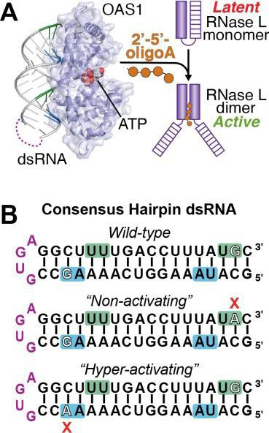2’-5’-oligoadenylate secondary messengers promote the dimerization and subsequent activation of RNase L (**Fig. 1A**) (7,8). Activated RNase L degrades both viral and cellular RNA to halt viral replication and limit the spread of infection (19-22). RNase L targets specific messenger (m)RNA transcripts encoding proteins known to regulate cell adhesion and proliferation (23) as well as ribosomal (r)RNA to prevent translation and viral spread to neighboring cells (24).

**OAS1 is activated upon binding viral dsRNA.** OAS1 lacks an RNA-binding motif and instead interacts with dsRNA through patches of positive residues on the protein’s surface (18). RNA binding to OAS1 requires double stranded regions with a minimum length of 18 base pairs (bp) (25). However, while OAS1 can be activated by dsRNA that meets this 18 bp requirement, activation is strongly potentiated by activating consensus sequences and the 3’-end single-stranded pyrimidine (3’-ssPy) motif that our lab recently identified (26-28). *However, how these molecular signatures in dsRNA affect the level of OAS1 activity, and thus the potency of its antiviral effect, is not well understood.*

The dsRNA used in previous structural studies (18) contained two overlapping and antiparallel copies of a known OAS1 activation consensus

**Fig. 1. OAS1/RNase L pathway and**

**dsRNA hairpin construct design.**

***A,*** Upon binding dsRNA, OAS1 forms

2’-5’-oligoadenylates which activate RNase L. The location of the stable

RNA tetraloop sequence added to my dsRNA constructs is shown by

sequence WWN9WG, where W is A or U, and N is any nucleotide (26). Although

one consensus sequence was present on each strand of the helix, the dsRNA bound OAS1 in a single, unique orientation (18). Our preliminary data indicate that selectivity in binding orientation also exists in solution and plays a critical role

in determining the potency of OAS1 activation. We designed a model dsRNA

the *dashed purple line* on the OAS1- hairpin construct based on the dsRNA used in these structural studies where the

dsRNA crystal structure (PDB 4IG8).

***B,*** The wild-type dsRNA hairpin

“wild-type” dsRNA strands are linked by a short stable loop (**Fig. 1B**). We chose

(*top*)_with two overlapping and anti- to use short dsRNA hairpins for the studies proposed here to simplify preparation

parallel copies of a known OAS1 activation consensus sequence

(shaded *blue* and *green*). The tetra- loop added to connect the strands is

in *purple*. Single G to A mutations that result in dramatic differences in

(by *in vitro* transcription), for ease of transfection, and because due to their small

size they should not activate other dsRNA sensors in cells. Two additional hairpin variants were also created where the G residue of one OAS1 consensus

sequence was mutated. This G residue (in the top strand, green shaded

OAS1 activation are indicated for the consensus; **Fig 1B**) was the only base-specific contact between OAS1 and the

“Non-activating” and “Hyper- activating” dsRNA hairpin variants.

RNA in the crystal structure (18). Remarkably, our preliminary data showed that

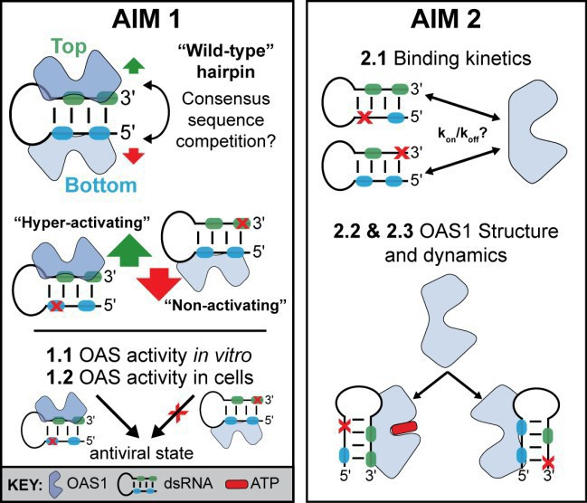while the mutation in the top strand consensus resulted in a complete loss of OAS1 activity (“Non-activating” variant), the equivalent change on the other stand *increased* OAS1 activity (“Hyper-activating” variant). Despite displaying stark differences in their ability to activate OAS1, both dsRNA hairpin variants retain the ability to bind OAS1 (see *Approach* section for details).

**Scientific Premise:** Although crystal structures have been solved of OAS1 in complex with dsRNA (18,29), we still do not fully understand the mechanisms OAS1 employs to discriminate between viral and cellular RNAs. Some previous work has been done to tease out the molecular requirements for OAS1 activation (18,25-27), but our lab’s recent discovery of the novel motif suggests our understanding of dsRNA-mediated OAS1 regulation is still incomplete (28). Based on the preliminary findings presented here, **I hypothesize that the dsRNA hairpin contains competing OAS1 binding sites with remarkably different capacities to activate the protein**. However, the molecular signatures defining these sites as activating and non-activating are not known. I will test my hypothesis through the following aims (summarized in **Fig. 2**). In **Aim 1**,

I will use OAS1 kinetics assays and RNase L activation in **Fig. 2. Summary of Aims.** In ***Aim 1***, I will test my model for

cells to define the features of dsRNA that lead to potent

competition between OAS1 binding sites (*top*) using complementary assays of OAS1 activation *in vitro* and in A549

OAS1 activation using the model dsRNA hairpins. In **Aim 2**, cells using the “hyper-activating” (*green arrow*) or “non-activating”

I will determine the molecular mechanism(s) by which the

(*red arrow*) dsRNA variants. In ***Aim 2***, I will examine RNA binding affinity and kinetics (*top*) and structural changes (*bottom*) to

“non-activating” and “hyper-activating” dsRNAs differ in their define the mechanistic basis to “hyper-activating” or “non-

interaction with OAS1 and effects on OAS1 structural activating” OAS1 binding sites in dsRNA.

dynamics. Through these complementary specific aims, I will determine how specific features in dsRNA and their context contribute to regulation of OAS1.

### APPROACH

**SPECIFIC AIM 1: Define dsRNA features and their context that lead to potent activation of OAS1. Rationale:** dsRNA binding to OAS1 requires a minimum of 18 bp and activation is potentiated by the presence of recently identified molecular signatures, including

However, how these molecular signatures act in concert or competition to affect the level of OAS1 activity and thus an innate antiviral response is unknown. Our preliminary data (**Fig. 3**) illustrate that

in each of the two consensus sequences leads to opposing affects: one no longer activates OAS1 (“non-activating”) while the other dramatically increases OAS1 activation (“hyper-activating”). Determining which RNA features create a preferred OAS1 binding site activating or non-activating will give critical new insight into how viruses could mask otherwise activating motifs to evade detection by the innate immune system. *Hypothesis: Extent of OAS1 activation is determined by the context of potentially overlapping RNA features with the ability to activate or inhibit OAS1.*

**Overview of Experimental Design:** I will examine how specific dsRNA features control the extent of OAS1 activity *in vitro* by using our established chromogenic assay (28) to measure OAS1 enzyme kinetics for the wild-type and each variant dsRNA hairpin (see **Fig. 1B**). I will next compare the differences in the ability of each dsRNA to activate OAS1 *in vitro* with their impact on the OAS1/RNase L pathway in living cells. These experiments will provide important new insight into currently unknown features of dsRNA that result in potent OAS1 activation *in vitro* and in human cells.

### Aim 1.1: Define the features of dsRNA that lead to potent activation of OAS1 *in vitro*.

**Experimental Approach:** I will *in vitro* transcribe the dsRNA hairpins from linearized plasmid DNA templates using T7 RNA polymerase and purify the RNAs by denaturing polyacrylamide gel electrophoresis using established protocols (30-33). Two “scrambled” versions of the dsRNA hairpin will also be transcribed as controls: Scramble 1 will maintain the wild-type activation consensus sequences, but will randomize all other nucleotides and in Scramble 2 all nucleotides will be randomized (while maintaining an 18 bp duplex in both RNAs). Human OAS1 will be expressed in *E. coli* BL21(DE3) and purified using sequential Ni2+-affinity, heparin-affinity, and gel filtration chromatography (28). I will use our lab’s established 96-well plate format *in vitro* chromogenic assay (28) to test the effects of mutations in defined RNA signatures in the dsRNA model

hairpin on OAS1 enzyme kinetics (**Fig. 3A**). This assay measures the amount of inorganic pyrophosphate (PPi) produced as a consequence of 2’-5’-oligoadenylate synthesis as a readout of OAS1 activity. The PPi is detected by quantifying the change in color (Abs at 580 nm) upon adding an ammonium molybdate reagent, as shown for the initial enzyme progress curves at a single concentration of the wild-type (*purple*), “non-activating” (*blue*), and “hyper-activating” (*green*) dsRNA hairpins (**Fig. 3B**). In this subaim, I will perform assays at a range of RNA concentrations to determine enzyme kinetic parameters (Vmax and Kapp) (28) to fully define the capacity of each RNA to activate OAS1 *in vitro*.

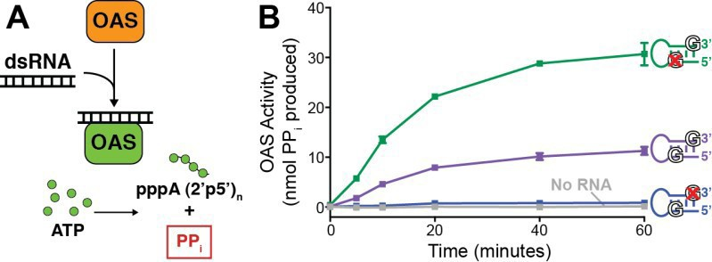I will also perform competition assays with a fixed amount of the “hyper-activating” dsRNA and titrating increasing amounts of the “non-activating” dsRNA. This experiment will directly test the consensus competition model and show that the “non-activating” RNA interacts with OAS1 (as suggested by preliminary binding data, see **Aim 2**). The following controls will be used in all experiments in this subaim: ATP

degradation (no OAS1), no RNA (negative),

**Fig. 3. *In vitro* OAS1 activation assay reveals stark differences between the**

**two consensus sequence variants. *A,*** OAS1 activity is measured via PP

poly(rI:rC) dsRNA (positive), wild-type and both production during 2’-5’-oligoadenylate synthesis. A color product is produced

scramble dsRNA hairpins.

**Data Analysis/Rigor:** To ensure rigorous and reproducible data are obtained, each experiment

upon the addition of ammonium molybdate and absorbance is measured at 580 nm using a BioTek Synergy 4 plate reader. ***B,*** OAS1 enzyme progress curves are shown for a single concentration of wild-type (*purple*), “hyper-activating” (*green*), and “non-activating” (*blue*) dsRNAs; a no RNA control (*grey*).

will be performed in three technical replicates and use at least two different preps of OAS1. Prep-to-prep

variation in OAS activity will be assessed and controlled for by including poly(rI:rC) dsRNA and wild-type dsRNA samples on each plate. After background correction, absorbance measurements are converted to nmol PPi produced using a standard curve of known PPi concentrations. Data will be averaged and plotted using standard error of the mean on GraphPad Prism software and curves will be fit using non-linear regression to obtain Vmax and Kapp values using the Michaelis-Menten model equation, Y=(VmaxX)/(Kapp+X).

**Outcomes/Interpretations:** This subaim will measure *in vitro* OAS1 enzyme activity to discern potential differences in OAS1 kinetic parameters (Vmax and Kapp) that lead to the dramatically different extents of OAS1 activation by the dsRNA hairpins suggested by the preliminary studies using single RNA concentrations (**Fig. 3B**). Our lab’s previous analysis of the (28) suggest that I may observe an increase in maximal enzyme rate (Vmax) for the “hyper-activating” and a decrease in this parameter for the “non-activating” dsRNA compared to “wild-type.” For each dsRNA, I may also observe a change in the apparent RNA affinity (Kapp). A decrease in apparent affinity from enzyme kinetic measurements for the “hyper-activating” dsRNA hairpin could, for example, reflect a mechanistic requirement for OAS1 to bind and release the dsRNA between rounds of catalysis. Competition experiments will explore a model that the “wild-type” dsRNA contains competing sites (productive vs non-productive); if the “non-activating” dsRNA can still bind OAS1 then it should be able to compete for binding (and thus regulation of OAS1) in *trans*. The mechanistic basis for the differences in OAS1 activation by different dsRNAs and the potential for competition between activating and inhibitory sequences with be fully explored in **Aim 2**. As these experiments progress, new dsRNA variants could be designed to answer additional questions such as whether consensus sequence position within the duplex influences activation by inserting/ deleting base pairs between the consensus G and the RNA terminus.

**Aim 1.2: Determine the ability of dsRNA hairpins to activate the OAS/RNase L pathway in living cells. Experimental Approach:** I will test the effects of the three dsRNA model hairpin variants (**Fig. 1B**) on OAS1 activation by transfecting each dsRNA into human lung carcinoma (A549) cells and measuring OAS/RNase L activity. A549 cells are optimal for these experiments as they express OAS1 without interferon stimulation, thus reducing the complexity of experimental design. I will transfect cells with my three dsRNA hairpins using lipofectamine 2000 (ThermoFisher) accompanied by the following controls: mock (no RNA), poly(rI:rC) dsRNA (positive control), and the scramble dsRNA hairpins (see *Aim 1.1*). Mock transfections will allow me to confirm that the transfection process does not stimulate an innate immune response as well as assess RNA quality during extraction. I will isolate total RNA from A549 cells at specific established time points (e.g. 1 and 3 hours) post-transfection (23,34). RNase L activity will then be determined by: 1) reverse transcription droplet digital PCR (RT ddPCR) with primers for known specific RNase L targets (FAT4, FREM2, PCDHB5, and ZEB1) (23), and 2) assess ribosomal RNA (rRNA) cleavage via agarose gel (23,35-37). Partitioning of cDNAs intodroplets

prior to amplification makes ddPCR ideal for detecting small differences between samples or minor species in a population (36). ddPCR also allows for absolute quantification of cDNA copy number without the need for a standard curve. Pre-determining the number of cells in the starting material allows back calculation and precise quantification of the number of mRNA transcripts per cell. rRNA cleavage assays will be used to visualize cleavage patterns characteristic of RNase L activation and is well established in the field (19,20,34,35). These two methods will allow me to measure a gradation of OAS1 activation (e.g. ddPCR is sensitive tool that will allow weak activation to be detected, whereas robust activation can be monitored by rRNAcleavage).

**Data Analysis/Rigor:** Each experiment will be performed in biological triplicates. Data will be plotted using GraphPad Prism software, replicates will be analyzed using standard deviation, and statistical significance determined using unpaired Student’s t-test (p<0.05).

**Outcomes/Interpretations:** I anticipate that the cell data will recapitulate my *in vitro* results on OAS1 activation, e.g. cellular mRNA and rRNA degradation following transfection with the “hyper-activating” and “non-activating” dsRNA hairpins will be significantly increased and decreased, respectively, compared to the “wild-type” RNA. These experiments will reveal the importance of the identified RNA signatures and their context on OAS1 activation in cells and will thus serve as an important validation of the *in vitro* enzymatic studies of this aim and the mechanistic studies in **Aim 2**. It is possible that differences in OAS1 (and thus RNase L) activation in cells might not be as dramatic as shown by the *in vitro* data. However, by testing RNAs with a range of potential capacities to activate OAS1, my experiments may reveal in more detail the nature of the cellular response to low extents of OAS1 activation. For example, does low level activation (which might reflect the early stages of infection) lead to only mRNA degradation, while extended time of high OAS1 activation subsequently results in additional degradation of the cellular translational machinery?

**Potential Pitfalls/Alternative Approaches:** The *in vitro* chromogenic assay outlined in *Aim 1.1* is for OAS1 enzyme kinetics assays established in our lab (28), and therefore I do not expect technical issues with these experiments. However, an alternative approach also used in our lab would be to analyze 2’-5’-oligoadenylate synthesis by [α32P]-ATP incorporation via denaturing sequencing gels (28). This method, unlike the chromogenic assay, is not high throughput but is useful to directly visualize 2’-5’-oligoadenylate products and measure very weak activation (18,25). In *Aim 1.2*, RT ddPCR is an established method that I have used in the Lowen lab previously (36) therefore I do not expect to run into technical issues adapting the method for the proposed analyses. However, qRT-PCR is an alternative method (23) that can be used if needed and is also well established in the Lowen lab. rRNA cleavage can also be determined using a Bioanalyzer (available in the Emory Integrated Genomics Core) if agarose gels prove to be inconclusive. Although my dsRNA constructs are designed to minimize activation of other innate immune sensor proteins in A549 cells such as dsRNA- activated protein kinase (PKR), if such issues are identified I would use knockout cell lines which have been constructed (38) or can be generated in the Lowen lab.

### SPECIFIC AIM 2: Determine the molecular mechanism(s) by which the “non-activating” and “hyper- activating” dsRNAs differ in their effects upon OAS1 activity.

**Rationale:** Our preliminary data suggest that dsRNAs may contain potentially competing OAS1 binding sites with remarkably different capacities to activate the protein (see **Aim 1** and **Fig. 3**). However, the molecular mechanisms defining these sites as activating and non-activating are unknown. Defining such differences will provide novel insight into the regulation of OAS1 and could reveal both potential new strategies to manipulate OAS1 for the design of effective treatments for viral infection and mechanisms by which viruses could potentially mask otherwise activating dsRNA motifs. *Hypothesis: “Non-activating” and “hyper-activating” RNAs exert their effects through different impacts on binding kinetics and/or OAS1 structural changes despite having similar binding affinity*.

**Overview of Experimental Design:** I will elucidate the molecular mechanism(s) responsible for the dramatic differences in OAS1 activation by the dsRNA hairpins by measuring binding affinity and kinetics (on/off rates) using bio-layer interferometry (BLI), comparing dsRNA-induced changes in OAS1 structural dynamics using hydrogen-deuterium exchange coupled with mass spectrometry (HDX-MS), and determining x-ray crystal structures of the “non-activating” and “hyper-activating” dsRNAs bound to OAS1. These experiments will reveal important new insight into the molecular mechanisms that modulate OAS1 activation.

**Aim 2.1: Determine the impact of dsRNA binding affinity and/or kinetics on OAS1 activation. Experimental Approach:** To immobilize OAS1 on a streptavidin biosensor for BLI OAS1-dsRNA interaction studies, I used inverse PCR to add an AviTag sequence to the C-terminus of OAS1 to create an OAS1-AviTag

construct (39,40). AviTag is a 15 amino acid tag (GSGLNDIFEAQKIEWHE) containing a specific recognition sequence for biotinylation by BirA biotin ligase (39). I purified biotinylated recombinant OAS1-AviTag from *E. coli* and showed, using the OAS1 activation assay (see *Aim 1.1*), that the C-terminal AviTag does not alter OAS1 activity (**Fig. 4A,B**). I have also shown that OAS1-AviTag can be successfully immobilized on streptavidin biosensors for RNA binding affinity (Kd) and kinetics (kon and koff) experiments on a state-of-art FortéBio OctetRED384 instrument (**Fig. 4C**) available to us through Emory’s Chemical Biology Discovery Center (*see letter from Dr. Du*). Preliminary BLI data shown here (**Fig. 4C**) not only demonstrates my ability to collect data using this method, but also the important finding that the “non-activating” dsRNA hairpin can still bind OAS1. Therefore, the observed non-activation by this hairpin in *Aim 1.1* (see **Fig. 3B**) is not due to lack of OAS1 binding. Experiments will be performed at a fixed density of OAS1-AviTag (e.g. 180s loading, 20 μg/ml) with increasing amounts of dsRNA (e.g. 0.1-100 μM). Each sensor will use a different RNA concentration and on/off rates will be measured by dipping sensors into RNA (*association*) and then into buffer (*dissociation*). Controls will include: OAS1 in buffer only (background) and biocytin (a biotin analog) with and without RNA.

Parameters that may require optimization include buffer conditions, OAS1 and dsRNA concentrations, molecule orientation, and reference sensors. I will test different assay buffers using the OAS1 activation assay (see *Aim 1.1*) buffer as a starting point. Loading density of biotinylated OAS1 and analyte concentration will be optimized to ensure the appropriate signal intensity is achieved. I will also verify that there is no preferred molecule orientation by performing experiments using immobilized biotinylated dsRNA. Although an important control, this set up is not ideal, as every dsRNA construct will need to be synthesized with a biotin modification.

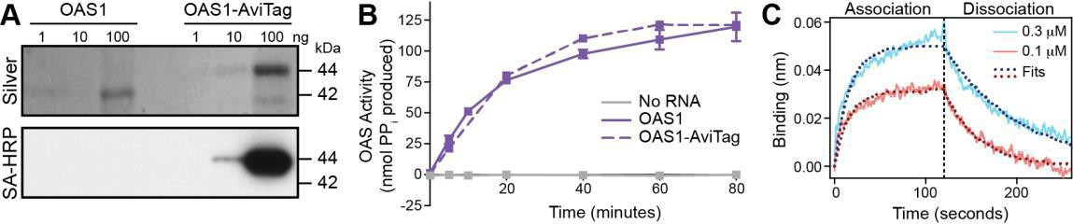**Fig. 4. OAS1-AviTag is active and can be biotinylated for BLI assays. *A,*** Serially diluted wild-type OAS1 and OAS1- AviTag were analyzed by SDS- PAGE and visualized using silver stain (*top*) or blotted with streptavidin-horseradish peroxidase (*bottom*). ***B,*** OAS1 activation by the “wild-type”

RNA hairpin is shown for wild-type OAS1 (*solid purple*) and OAS1-AviTag (*dashed purple*). OAS1 activity was also measured using a no RNA control (*grey*). **C*,*** OAS1-AviTag was immobilized on a streptavidin biosensor and the “non-activating” RNA hairpin was added at 0.3 mM (*blue*) and 0.1 mM (*red*). Dotted lines show the curve fits for each concentration. These data show that OAS1-AviTag is specifically biotinylated, retains enzyme activity, and preliminary BLI data demonstrate our ability to measure protein-RNA binding affinity andkinetics.

**Data Analysis/Rigor:** Data will be subtracted from reference streptavidin sensors coated with biocytin. After background correction, the interference shift (in nanometers) is plotted, fit, and analyzed using the Octet Data Analysis Software. To ensure rigorous and reproducible data, each experiment will be performed in three technical replicates using at least two different preps of OAS1 to address prep-to-prep variability.

**Outcomes/Interpretations:** If the ability of a dsRNA to activate OAS1 is *dependent* on binding affinity or kinetics I expect to identify significant differences between “non-activating” and “hyper-activating” dsRNAs. For example, I may find that differences in binding affinity whereby higher affinity is correlated with either the more or less activating dsRNA. For the “hyper-activating” dsRNA, higher affinity could result in a great ability to drive OAS1 conformational changes (see *Aim 2.2*), while lower affinity with altered kinetics would be consistent with a mechanistic requirement to bind and release dsRNA between rounds of catalysis. It is thus also possible that the functionally critical difference could be based in alteration of a specific kinetic parameter (kon and/ or koff); a kinetic basis for regulation would be a novel finding. If both dsRNAs have the same (or similar) affinity and kinetics, this would suggest that binding differences are not the basis for their distinct capacities to activate OAS1. In this case, I will focus on the protein dynamics and structural approaches in *Aims 2.2 and2.3*.

### Aim 2.2: Define the role of dsRNA-driven structural changes in OAS1 enzyme activation.

**Experimental Approach:** I performed an OAS1 peptide mapping experiment by in-line pepsin digest and MS on our HDX-MS system (*see letter from Dr. Li*) revealing my ability to achieve 100% OAS1 sequence coverage and high (33-fold) redundancy (**Fig. 5A**). An earlier comparative deuterium exchange experiment showed that OAS1 residues dsRNA-induced conformational changes (18), exhibited high deuterium uptake in *apo* OAS1, indicating the dynamic nature of these residues in the absence of RNA (**Fig. 5B**). These data show that HDX/MS will be an ideal tool to monitor differences in the capacity of my dsRNAs to functionally alter the OAS1 structure. I will therefore use HDX-MS to examine differences in OAS1 protein conformational dynamics in the absence or presence of the “wild-type,” “non-activating,” and “hyper-activating” dsRNA hairpins (see **Fig. 1B**). The automated system adds deuterium-containing solution to the sample (OAS1 alone

or OAS1-dsRNA complex), quenches the reaction at 4-5 individual time points (e.g. 0, 15, 60, 180, 600 seconds), and injects the samples individually onto the in-line pepsin column prior to MS analysis. Differential deuterium uptake in each measured OAS1 peptide (*apo* vs each dsRNA, “hyper-activating” vs “non-activating”) will be calculated and mapped on to the OAS1 structure.

**Data Analysis/Rigor:** Duplicate experiments will be conducted using protein from independent preps, with six separate injections of each sample into the MS to ensure high redundancy. I will analyze the data in the HDX core with Masslynx 4.1, PLGS 3.0, and Dynamix 3.2 software.

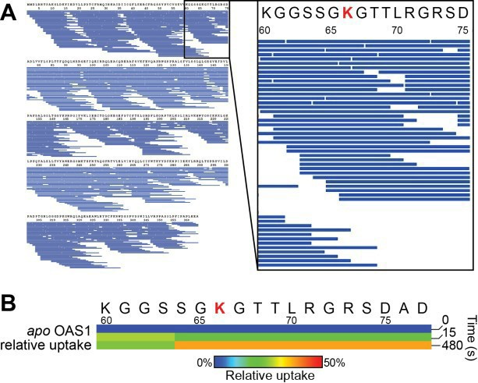**Outcomes/Interpretations:** If an ability to drive changes in OAS1 conformational dynamics contributes to differences observed in OAS1 activation, I expect that the “hyper- activating” dsRNA will causechanges in and potentially other *activating* changes elsewhere in OAS1. In contrast, the “non-activating” dsRNA may fail to induce the functionally critical changes in or may cause additional *inhibitory* changes that contribute to loss of OAS1 activation. The role of newly identified regions in OAS1 that may be allosterically regulated by dsRNA could next be tested by mutagenesis and functional analyses like those of **Aim 1**.

### Aim 2.3: Determine structures of ‘non-activating’ and ‘hyper-activating’ dsRNA in complex with OAS1.

**Experimental Approach:** We have obtained initial crystals

from 96-well screens for both the “non-activating” and “hyper- **Fig. 5. Preliminary HDX-MS data. *A,*** OAS1 mapping activating” dsRNA complexes with OAS1 that diffract to experiment demonstrating the potential for acquiring high medium resolution (~7 Å) (**Fig. 6**). I will next optimize these quality HDX-MS data (100% coverage, 33-fold redundancy). crystals using additional screens around the initial conditions, Each blue bar represents a unique peptide and the zoomed in adjusting parameters such as the concentrations of OAS1- conformational change upon dsRNA binding. ***B,*** Deuterium

region shows the loop which undergoes

dsRNA complex, salt, or precipitant, pH, and temperature. If uptake from a pilot exchange experiment. These data show

needed, I will also test detergents and other additives to

uptake *only* for demonstrating that RNA- induced changes can be monitored by this method. [Data in

improve crystal formation. Diffraction data sets will be collected *panel B* collected by G. Conn].

at the SER-CAT beamline at the APS. Once suitable quality data are obtained, I will determine the structure by

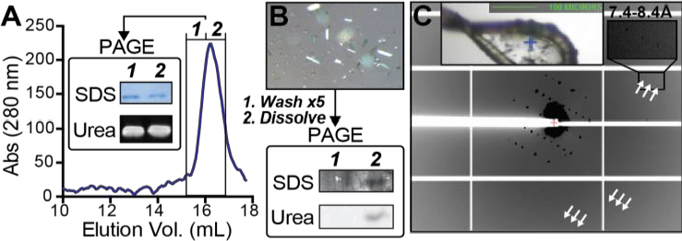molecular replacement using the structure of RNA- bound OAS1 (PDB 4IG8) as a starting model. Our lab has all the software needed for structure determination, including *HKL2000* for X-ray data processing (41); *Phenix* for molecular replacement, refinement, and validation (42); and *Coot* for manual model building (43).

**Fig. 6. Crystallization of OAS1:dsRNA complexes. *A,*** OAS1 and dsRNA **Data Analysis/Rigor:** Structures will be validated co- elute from a Superdex S200 gel filtration column. ***B,*** Demonstration that during refinement with Phenix (42), and I will use the crystals contain both RNA and protein. Crystals were (*1*) washed five times Protein Data Bank (PDB) server to ensure our data

with crystallization solution then (*2*) dissolved and analyzed by PAGE. ***C,***

Diffraction from a crystal taken from the drop shown in *panel B* extends to at

and final structures are of optimal quality prior to

least 7Å (*white arrows*). These data demonstrate our ability to crystallize deposition (44).

OAS1 with a dsRNA hairpin from our library. [Data collected by B. Calderon

and G. Conn]. **Outcomes/Interpretations:** Structures of the OAS1-

dsRNA complexes will reveal the molecular details underpinning the differing ability of each dsRNA to activate OAS1. These structures will provide a detailed platform for interpretation of my findings in other subaims as well as allowing me to develop and test (by mutagenesis and functional assays) new hypotheses about critical OAS1-dsRNA interactions for potent activation or for dsRNA binding in the absence of OAS1activation.

**Potential Pitfalls/Alternative Approach:** My preliminary data indicate BLI will be applicable to OAS-dsRNA binding affinity/ kinetics but, if needed other approaches are well established in our lab (45-47) and several options are available (e.g surface plasmon resonance or isothermal titration calorimetry in the Emory Comprehensive Glycomics core). I also do not anticipate technical issues with HDX-MS as our preliminary data (**Fig. 5**) clearly support the feasibility of this approach. Finally, X-ray crystallography is inherently full of potential pitfalls but progress in obtaining diffracting crystals of both complexes and our lab’s track record in structure determination (48-54) give strong cause for optimism that I will obtain high-resolution structures.